Practical No. 8
Aim : ALP for Sum of series of Hexadecimal numbers
Name : Danish Altaf Solkar Class : CO - B
Enrolment no. : 24111590805 Batch : 2

Code :-
assume cs:code
assume ds:data
data segment
arr DB 10H,20H,30H,40H,50H
res DW ?
data ends
code segment
start:
MOV AX,data
MOV DS,AX
MOV AX,0000H
LEA SI,arr
MOV CL,04H
MOV AL,[SI]
UP:
INC SI
MOV BL,[SI]
ADD AL,BL
JNC DOWN
INC AH
DOWN:
LOOP UP
MOV res,AX
INT 03H
code ends
end start

OUTPUT :-
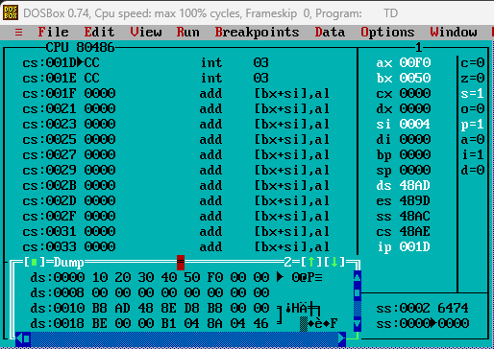

Process related  (15) | Product related  (10) | Total Marks  (25) | Signature

